Policy and Process for Formulating Program Educational Objectives (PEOs)

Policy Statement
At Mar Baselios Christian College of Engineering & Technology (MBCCET), Program Educational Objectives (PEOs) are vital for defining the long-term goals and outcomes expected of graduates in their professional and societal roles. These objectives reflect the institution’s vision and mission, the expectations of stakeholders, and emerging trends in engineering education, industry, and society. This policy ensures that the process of formulating, validating, disseminating, and periodically reviewing PEOs is structured, participatory, and quality-driven. The process for defining the statements are shown in figure 1.
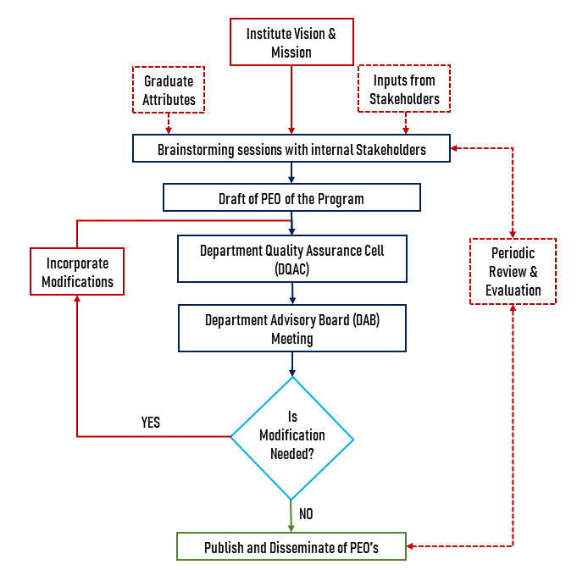
Fig. 1 Process for Defining Program Educational Objectives of the Department

Objectives of the Policy

To define clear and achievable long-term objectives for graduates of each program.

To ensure alignment of PEOs with:

The Vision and Mission of the institution,

Graduate attributes as prescribed by AICTE/NBA/KTU,

Stakeholder expectations.

To implement a systematic and inclusive process for formulation and review of PEOs.

To support the continuous quality enhancement of academic programs.

Scope
This policy applies to all undergraduate and postgraduate academic programs offered by MBCCET under the affiliation of Dr. APJ Abdul Kalam Technological University (KTU).

Process for Formulating Program Educational Objectives (PEOs)
The process is structured as follows:

Input Collection
Inputs are obtained from:

Institute Vision and Mission

Graduate attributes defined by national regulatory bodies (AICTE, NBA, KTU)

Feedback from stakeholders:

Employers/Industry representatives

Alumni

Faculty members

Students

Academic experts
Methods used:

Surveys and structured interviews

Alumni and employer feedback reports

Curriculum review workshops

Drafting PEOs

A Program-level drafting team (led by the Program Coordinator/HoD) develops a preliminary set of 3–5 PEOs.

Draft PEOs are:

Broad, realistic, and measurable 3–5 years after graduation

Focused on career progression, higher education, lifelong learning, ethics, and societal contribution

Aligned with program outcomes (POs) and institutional values

Internal Review – DQAC

The draft PEOs are reviewed by the Department Quality Assurance Cell (DQAC), consisting of:

HoD

Senior faculty members

The review ensures:

Alignment with institutional mission

Relevance to the current academic and professional environment

Clarity and consistency of language

External Review – DAB

The draft is presented to the Department Advisory Board (DAB).

The DAB includes:

Senior faculty

Alumni

Industry experts

Academic experts

Based on the feedback, the PEOs are either:

Finalized, or

Returned to DQAC for modification and resubmission

Final Approval and Dissemination

Once approved by the DAB, the final PEOs are:

Published on the institutional and departmental websites

Printed in academic handbooks, curriculum files, and brochures

Displayed in classrooms, labs, and student information boards

Periodic Review and Revision

PEOs are reviewed at least once every 3 years, or:

When significant curricular revisions are made

Based on alumni/employer feedback

In response to accreditation or regulatory recommendations
The same stakeholder-involved process is followed during review to ensure continued relevance and quality.

Alignment of Program Educational Objectives (PEOs) with Department Mission Statement
To ensure consistency between the Program Educational Objectives (PEOs) and the mission statement of the department, it is essential to begin with a thorough understanding of the department’s mission, which typically reflects its commitment to providing quality technical education, fostering research and innovation, promoting ethical and societal responsibility, and encouraging lifelong learning. The PEOs should be carefully formulated to directly support and reflect these core elements of the mission. Each PEO must articulate broad career and professional achievements expected of graduates a few years after graduation, and these should align with specific aspects of the mission. For example, a mission element focusing on technical excellence should be reflected in a PEO that emphasizes graduates’ ability to apply engineering knowledge in professional practice. Similarly, a mission that promotes societal responsibility should be supported by a PEO highlighting ethical practices and contributions to community welfare. By clearly aligning each PEO with the department’s mission, the institution ensures a coherent and mission-driven educational strategy.

Prepare a PEO–Mission Matrix (Mapping Table)
Create a matrix/table showing the correlation between each PEO and each clause of the department’s mission.
PEO / Mission | Mission 1 | Mission 2 | Mission 3 | Mission 4
PEO 1 | ✔️
PEO 2 |  | ✔️ |  | ✔️
PEO 3 | ✔️ |  | ✔️
Use checkmarks or numerical scale (1: Low, 2: Medium, 3: High) to show the degree of alignment.

Roles and Responsibilities
Task | Responsible Entity
Input collection | HoD, Program Coordinator, IQAC
Drafting of PEOs | Program Faculty / HoD
Internal review | Department Quality Assurance Cell (DQAC)
External review and approval | Department Advisory Board (DAB)
Dissemination | Program Coordinator / Website Committee
Periodic review and revalidation | DQAC / IQAC / DAB

Expected Outcomes

PEOs that are outcome-oriented, measurable, and relevant to future professional needs.

Stakeholder-informed academic programs aligned with global standards and societal expectations.

A structured and traceable process for continuous academic improvement.

